Guideline & Template
For
Graduation Project I and II
CIS Department

Prepared by:
- Eyad Alshareef
- Mustafa Radiada
- Hesham Abanda

Revised by:
Dr Ahmad Alaiad
GRADUATION PROJECT GENERAL REQUIREMENTS

- Format
You can easily use the template attached to this document as reference
A. Minimum of 20 typed pages
B. Title page (not included in 20 page requirement)
C. Times New Roman font
D. 12 point font
E. One inch margins
F. 3 hard copies of your project (submitted to the project coordinator) + 2 CDs of the implementation code
G. Students MUST work in groups

II. Evaluation
- Grading
Graded by the adviser (XX%) and project committee (XX%)
B. Content
1. Specific, accurate, precise information/data
2. Thoughtful conclusions supported by information or data
3. Precise, accurate vocabulary
4. Insight regarding the importance and value of the project
C. Organization
1. Logical order of information based on topic
2. Engaging beginning and thoughtful ending
3. Clear focus on controlling idea.
4. Transitions between ideas
D. Research
1. Variety of sources appropriate to study
2. Credible, timely resources
E. Conventions of Language
1. Varied and structurally correct sentences
2. Correct mechanics, grammar and word usage

Checklist for Student Oral Presentation

This checklist is meant to guide you in preparation for a successful oral presentation of your graduation project:
- Introduce yourself to panel members
- State the type of project you did.
- State the problem you plan to address
- State the importance of your project and practical implications
- Describe, in detail, the procedures you followed in completing your project.
- Explain what you learned while completing your project.
- Describe how your project has impacted your personal growth.
Conclude your presentation by asking the panel members for questions

The oral presentation will be judged on the basis of the following categories:

- Content, which includes
- XX minute minimum presentation
- Supporting information
- Conclusions
- Importance, value, or impact of the project
- Sources of information
- Vocabulary relevant to the topic

- Effective speaking, which includes
- Presenting one’s self with poise
- Maintains consistent eye contact with the review panel
- Varies tone, volume, and speed to enhance presentation
- Speaks alone, without the aid of an interpreter

- Organization
- Is appropriate to the study
- Use of an engaging beginning and thought fending
- Supports a clear idea
- Flows smoothly from one idea to the next

- Visual Media
- Effective use of graphic design
- Communicates significant information
- Clearly, accurately, and precisely communicates information
- Photos should be organized in an album, or placed in a computer/slide presentation

- Response to questions
- Effectively responds to all questions from the panel
- Uses questions from the panel to illustrate the idea

Cover page



Jordan University of Science and Technology
Faculty of Computer and Information Technology
Computer Information Systems Department

[Name Of Project]
for Faculty of Computer and Information Technology

By:
[Name of student]

[Graduation project [1, 2] ]

Submitted in partial fulfilment of the requirements
for the award of
Bachelor degree
of the
Jordan University of Science and Technology

[Supervisor: Dr. ]
Faculty of Computer and Information Technology

PROJECT PROPOSAL
Deadline: 2nd week of the semester

Form No.1

GRADUATION PROJECT PROPOSAL

Student Name ____________________________________________________________________

Student ID #______________ Grade __________ Email ______________________________

Project Title _____________________________________________________________________

Brief Description
[

]

Project goal – Why did you choose this particular project? What do you plan to learn from this experience?
[

]

Plans to achieve this goal – Timeline:
[

]

Student Signature ______________________________________________________________

Project coordinator signature __________________________________________________________________

For project committee

Approved Rejected Approved with conditions

Comments:

Committee chair signature
Date:

Project Progresses Activities [log]

Form No 2

Student Name ____________________________________________________________________

Student ID #______________ Email _______________________________________________

Project Title ______________________________________________________________________

The daily and weekly activities of the project

Date | Activates/ Explanations | Time spent | supervisor signature

Student’s Signature: _________________________________

Mentor’s Signature: _________________________________

Supervisor’s Signature:

Graduation Project Evaluation

Forms NO 3

Graduation Project Evaluation

Department of Computer Information Systems

GRADUATION PROJECT

Project Title:
[

]

Supervisor:

Final Grades

Student name | Evaluation committee  (average)  XX% | Supervisor  XX% | Total  100%

Signatures:

1. Project's Coordinator: …………………………………………

2. Head of Department: …………………………………………

Date: ___________________

Evaluation Form for CIS 491
Jordan University of Science and Technology
Faculty of Information Technology and Computer
Department of Computer Information System
Evaluation Form Graduation Project I (CIS491)
(Documentation, Presentation)
Advisor Form

Student name
Student number
Project name

Criteria | Grade
1) Is the cover letter included in the report? | 5%
2) Is the cover letter formatted properly (CL1 style)? | 5%
3) Is the table of content included in the report? | 5%
4) Is the table of content created automatically? | 5%
5) Are the introduction and subsequent chapters embedded in the report? | 5%
6) Is the report written very well (grammatical and syntax errors)? | 5%
7) Is the presentation on the topic clearly understood? Are the sentences readable and understood? | 5%
8) Are the paragraphs logically connected? | 5%
9) Are the figures and tables clear and formatted properly (FT2 style)? | 5%
10) Following up with the advisor, commitment to the meetings and working with the team. | 30%
11) Submitting the report on time and the overall structure of the report is properly prepared? | 10%
12) The presentation of the project to the committee:  -Starting on time  -Finishing on time  -Dressing and appearance  -Self-confidence and delivering the ideas  -Answering to the committee questions | 15%
Total | 100%
 | 50%

Evaluation Form for CIS 491

Jordan University of Science and Technology
Faculty of Information Technology and Computer
Department of Computer Information System
Evaluation Form Graduation Project I (CIS491)
(Documentation, Presentation)
Examiner Form

Student name
Student number
Project name

Criteria | Grade
1) Is the cover letter included in the report? | 5%
2) Is the cover letter formatted properly (CL1 style)? | 5%
3) Is the table of content included in the report? | 5%
4) Is the table of content created automatically? | 5%
5) Are the introduction and subsequent chapters embedded in the report? | 5%
6) Is the report written very well (grammatical and syntax errors)? | 5%
7) Is the presentation on the topic clearly understood? Are the sentences readable and understood? | 5%
8) Are the paragraphs logically connected? | 5%
9) Are the figures and tables clear and formatted properly (FT2 style)? | 5%
10) The presentation of the project to the committee:  -Starting on time  -Finishing on time  -Dressing and appearance  -Self-confidence and delivering the ideas  -Answering to the committee questions | 5%
Total | 50%
 | 25%

Evaluation Form for CIS 492

Jordan University of Science and Technology
Faculty of Computer and Information Technology
Department of Computer Information Systems
CIS492 Graduation Project II Evaluation Form
(Documentation, Presentation)
Advisor Form

Student Name
Student ID
Project name
 | Score
1) GP2 report consists of GP1 report and the implementation part details of the project. | 5%
2) GP2 report has no syntax or semantic errors. | 5%
3) The student was well dressed, and presented the project on time. | 5%
4) The student explained the problem and the contribution in a good manner. | 5%
5) The student answered all questions correctly. | 5%
6) The project report has missing parts or some parts do not work correctly. | 5%
7) The level of accomplishment in comparing to existing solutions. | 10%
8) The novelty of the contribution | 10%
9) The student attendance and the degree of his/her collaboration with other team members. | 40
10) Delivering the complete project material on time. | 10
Sum | 100%
 | 50%

Evaluation Form for CIS 492
Jordan University of Science and Technology
Faculty of Computer and Information Technology
Department of Computer Information Systems
CIS492 Graduation Project II Evaluation Form
(Documentation, Presentation)
Examiner Form

Student Name
Student ID
Project name
 | Score
1) GP2 report consists of GP1 report and the implementation part details of the project. | 5%
2) GP2 report has no syntax or semantic errors. | 5%
3) The student was well dressed, and presented the project on time. | 5%
4) The student explained the problem and the contribution in a good manner. | 5%
5) The student answered all questions correctly. | 5%
6) The GP2 report has missing parts or some parts do not work correctly. | 5%
7) The level of accomplishment in comparing to existing solutions. | 10%
8) The novelty of the contribution | 10%
Sum | 50%
 | 25%


<Project Title>

Presented to the Faculty of Computer and Information Technology,
Jordan University of Science and Technology

In Partial Fulfillment
of the Requirements for the Degree of
Bachelor of Science in Computer Information Systems

By:
<Student Name 1>
<Student Name 2>
<Student Name 3>

Supervised By:
<Instructor Name>

Irbid, Jordan
Fall 2017

ABSTRACT

The ABC System is a __________________________. The goal of the system was to ___________________________________________________________________________
___________________________________________________________________________.
The system created to be used by ____________________________________________________________________________. The system created to be available on ____________________________ website which makes the system accessible at all times and anywhere by simply using a web browser and Internet connectivity.
This research project present the main steps that led to the creation of the system, starting from gathering data about different reporting systems that were available on the Internet and reviewing them. Then, specifying the requirements using Use Case analysis method that was needed to accomplish the design and development phase of the system. The last step was implementing the system.

ACKNOWLEDGEMENT
We are very thankful to everyone who supported us complete this paper effectively. We would like to thank our advisor Dr. ___________ for _________________

Table of Contents
1 Introduction 8
1.1 Introduction 8
1.2 Background 9
1.3 Problem statement 10
1.4 Required tools 16
2 Literature review 19
2.1 Articles Background (Optional) 19
2.2 Tools background 20
3 Requirement analysis: 30
3.1 Introduction 30
3.2 Work progress 30
3.2.1 Business Requirements identification: 30
3.3 Data Flow 42
4 System Design 43
4.1 Introduction: 43
4.2 User interface design 43
4.2.1 Site Map 44
4.2.2 Story board 45
4.3 Data Model 56
5 Conclusion 59
5.1 Conclusion: 59
5.2 Difficulty faced: 59
5.3 Future Works: 61
6 Reference 62

List of Figures
Figure Name Page
Figure 1 Name 5

List of Tables
Table Name Page
Table 1 Name 9

Introduction

Introduction
Give a general introduction about the project area.
For example, if the project is about information security, give an introduction about information security, tools and the importance of securing systems.

Background

Describe the area of your project in more details. For example, in information security, if you work on the public encryption specifically RSA, explain the public encryption in details and explain the RSA and how it works.

Problem statement
Describe the problem that pushed you to choose your project.

Importance of the project
Describe why your project is important.

Required tools
This section provides a brief description of the major software tools to be used in developing the application. For example, Microsoft SQL server, Microsoft visual studio, Microsoft Viso, Adobe Photoshop, Visual Paradigm, MySQL workbench and Pidoco.

Examples is shown next:

Microsoft SQL Server:
It is a Relational Database Management System (RDMS) that uses the Structured Query Language SQL to access and manipulate stored data developed by Microsoft. It is a software product whose primary function is to store and retrieve data as requested by other software applications. Its scope includes data query and data update, schema creation and modification and data access control. In SQL server, the RDMS is integrated within the visual studio IDE to simplify data access from windows applications. (About Microsoft SQL, 2012)

Microsoft visual studio:
Microsoft Visual Studio is an integrated development environment (IDE) from Microsoft. It is used to develop console and graphical user interface applications along with Windows Forms applications, web sites, web applications, and web services in both native code together with managed code for all platforms supported by Microsoft Windows, Windows Mobile, Windows CE,.NET Framework, .NET Compact Framework and Microsoft Silverlight. (What is Visual Studio?, 2012)

Adobe Photoshop:
Adobe Photoshop is a computer application developed by Adobe Systems Incorporated. It is developed to be used for manipulating images and pictures. It’s considered the mostly known and used among graphical applications. Photoshop has various proprieties and features that facilitate the manipulation of images included in the application. (About Photoshop, 2012)

Microsoft Visio:
Microsoft Visio is a commercial diagramming program for Microsoft Windows that uses vector graphics to create diagrams. It can be used to create all types of diagrams, from simple flowcharts to complex ERDs. (Microsoft Office Visio, 2012).

Literature review

Research Articles (Optional)
Discuss some articles in the area of your project.

Tools Background
Discuss some related tools to your project and how your project is different.

Requirement analysis and specifications

Introduction:
The main objective of this chapter is to provide a concise idea of the system and the work progress activities taken to develop the system. A detailed description of the functional and non-functional requirements of the system in addition to the user requirements is included. Also an overall description of the system is included. In short, this chapter focuses on the analysis phase of the system development life cycle.

Work progress:
This section gives a detailed description of the work progress and activities taken in order to derive the portal. This includes: candidate projects, and business requirements identification.

The client’s current inventory management system lacked the ability to control the entering of orders as they were delivered to the customers. The problem existed because there are three possible situations when delivering a product. The currently used system was not able to track that. Also the customers submitted their order requests through different mediums (depending on the customer’s preferences) and this made it impossible for the client to trace and document the requests.

Business Requirements identification:

Obtaining the business requirements of the system is a vital stage of the system development life cycle. Using iterative model as a software development method made it possible for us to mend and enhance the requirements of the system as the project advanced from one phase to another. Interviews and meetings with the client were held to gain the complete understanding of the system specifications. The following illustrates the software requirements, the functional requirements and nonfunctional requirements of the system.

User functional requirements:
This section illustrates the user requirements of the system. The following requirements are suggested by the system developers themselves to be verified later by the client. For example if there are four types of users for the Project System: Customers, Sales Representatives, Admins (Branch Managers), and warehouse representatives.
- All users should be able to interact with the application using both mouse and keyboard.
- The admin should be able to add, delete, and modify the system’s database.
- The admin should be able to modify the structure of the web pages.
- The admin should be able to add or remove some users.
- The admin should be able to monitor the Web pages.
- The admin should be able to specify the authority of users.
- The customer should be able to log in to his account using the log in data provided by his sale’s representative.
- The customer should be able to view the catalog of products available by the system.
- The customer should be able to fill an order form to order online.
- The customer should be able to track his shipment using the system.
- The customer should receive notification emails with any change that happens to his shipment or order.
- The sales representative should be able to log in to his account using the log in data provided by his manager.
- The sales representative should be able to view the list of customers he has.
- The sales representative should be able to edit the price of products for each customer and edit the promotion available for each customer.
- The sales representative should get a notification email once one of his customers places an order with the order number.
- The branch manager should be able to edit the inventory.
- The branch manager should be notified by email once and order is placed.
- The branch manager should be able to view the order and check the history of the customer’s balance.
- The branch manager should be able to view the inventory availability.
- The branch manager should be able to accept or reject an order.
- The branch manager should be able to generate reports regarding the pending, closed, in progress, and rejected orders.
- The warehouse representative should be notified once an order is approved.
- The warehouse representative should be able to login to the system and view orders that are in progress.
- The warehouse representative should be able to prepare and send the invoice to the accounting department.
- The warehouse representative should be able to prepare and send the delivery form.
- The warehouse representative should be able to follow up on the shipment status and update it to allow tracking.
- The warehouse representative should be able to close an order and record the transaction in the database once and order is fully sent and the invoice is stamped by the customer for receiving the shipment.

System Non-Functional Requirements:
This section presents other non-functional requirements to be taken into consideration when implementing the required application. In order to simplify the design, facilitate delivery of a demonstration application the following requirements and assumptions have been defined :

System Assumptions:
Examples of Assumptions:

- The client has exactly six warehouses across the kingdom.
- There will be exactly one supplier.
- The supplier supplies a limited number of products.
- All warehouses stock all products.
- An order may contain multiple line items, where each line item relates to a specific product and quantity required. A product shall not appear more than once in an order.
- There are no minimum order quantities, and quantities express units of one.
- Partial shipments of a single product are supported; either the required quantity of a product in a line item can be fulfilled in full or some of it.
- The requested quantity of a product must be shipped by a single warehouse, or none are shipped i.e. it is not possible to split the shipment of a product across warehouses.
- Back orders are supported; the required quantity of product can be fulfilled in full by a single warehouse or partially.
- The costumer’s information (payment details, address, etc.) are known to the client system via an implicit login.
- Payment is not demonstrated, it is assumed that a customer has pre-registered credit card details and billing happens.
- The start of each purchase use case assumes state is set back to predefined values i.e. predefined stock levels, min/max levels, etc.
- When a purchase request brings a warehouse quantity to below a certain level, the warehouse makes a request to the supplier for more goods.

Non-Functional Requirements:
Examples of Non-Functional Requirements:

- Portability: The system shall be easily and quickly ported to any server
- Speed: The system shall load the selected page with no more than 30 seconds.
- Scalability: The system shall adopt the addition of new chapters and or activities when needed.
- Availability: There are two key concepts for availability when it comes to this system:
  - Hours of operation: The system should be available 24 hours a day, 7 days a week. Given that 2 hours on Friday will be scheduled for Maintenance.
  - Reliability. The system should be reliable at all times and by all users.
- Capacity: This system should handle the load of data and transactions that will take place through it. It should handle growth in number, and the rush hours of usage
- Data currency: The system should always have up to date data. Real time updates, and delays are not acceptable.
- Data retention: The system should be able to store only the useful data, and data that will be used later on.
- Disaster recovery: The system should be able to recover from an outage.
- Error-handling: The system should be able to handle unexpected situations such as purchase orders for unrecognized products
- Internationalization: The system should be user friendly with people from different backgrounds and languages.
- Logging: The system should keep track of its activity. This provides an audit trail that can be used for problem-solving.
- Security: The system needs to handle customer privacy as well as user privileges securely and prevent any unauthorized access to the data.
Upgradeability: There should be an ease of replacing a component in a system with another one.

System functional requirements:
Examples of Functional Requirements:

- The system should display a welcome message and a login button for the user to get through the portal.
- The system should provide an interface were each sales representative can log in using his username and password.
- The system will enable sales representatives to insert and edit data regarding their customers.
- The system will log out from the sales representative profile if the representative clicks
log out button (log out from account).
- The system should provide an interface were each customer can log in using their username and password.
- The system should allow the user to fill in their orders by providing them with an order form.
- The system should send emails to both the sales representative and the customer to notify them with the order number.
- The system will log out from the customer profile if the customer clicks
log out button (log out from account).
- The system should provide an interface were the branch manager can log in using his username and password.
- The system should notify the branch manager of all the pending orders.
- The system should allow the branch manager to view the client history (balance) and the current inventory to check for availability.
- The system should permit the manager to reject the order and give his reasons or accept the order.
- The system should notify the client via email with the manager’s approval or rejection with reasons.
- The system should allow the manager to query for these reports:
  - Open orders (pending orders to be checked)
  - Orders in progress (confirmed orders)
  - Closed orders (completed orders)
  - Back orders ( orders not completely sent)
- The system will log out from the branch manager profile if the manager clicks
log out button (log out from account).
- The system should generate a “pick slip” once the order is approved.
- The system should provide an interface were representatives at the warehouse can log in using their username and password.
- The system should send the pick slip to the warehouse interface.
- The system should prepare the order invoice.
- The system should send order invoice to the accounting department.
- The system should send delivery form to the shipment driver.
- The system should activate system tracking.
- The system should provide the status of every shipment as it moves and changes from one place to another.
- The system should allow the client to login and check the status of his order being shipped.
- The system should allow the warehouse representative to update the delivery status either order is all received (order closed), or order is all rejected (order cancelled) or order partly rejected (order kept open and a reason provided).
- The system will log out from the warehouse representative profile if he clicks
log out button (log out from account).
- The system should provide a home button that brings the user back to his homepage which is activated when the user clicks the home button.
- The system should provide a help button to guide any of the users through the portal which will activate when the user clicks the help button.
- The system should provide an about us button for customers to know more about our organization which will activate as the user clicks the about us button.
- The system should provide a contact us button for clients who need to contact the organization which will activate when the user clicks the about us button.
- The system should provide an attach button to allow authorized people to attach documents onto the system activated by clicking the attach button.
- The system will display user’s account (history activity) if the user clicks on user history button.
- The system will display user’s recent updates if the user clicks on recent updates button.

System Design

Introduction:
The key objective of this chapter is to provide a clear understanding of the system structure, behavior, and views of a system. In short, the data modeling presented by an ER diagram, and the user interface storyboard are included in this chapter in addition to other model seen below.

Context Diagram
Provide a brief description and Draw context diagrams of your project level 0, 1 and 2.

Use case diagram
A use case diagram is one of the behavioral diagrams defined by the Unified Modeling Language (UML) for the purpose of describing the functional behavior of the system from user point of view. A use case diagram shows a graphical overview of the system functions in terms of actors and their goals represented as use cases.
For example, the following diagram shows the use case diagram of some project of four main users: customer, sales representative, manager, and the warehouse representative. A use case diagram that combines all users is presented in this section.
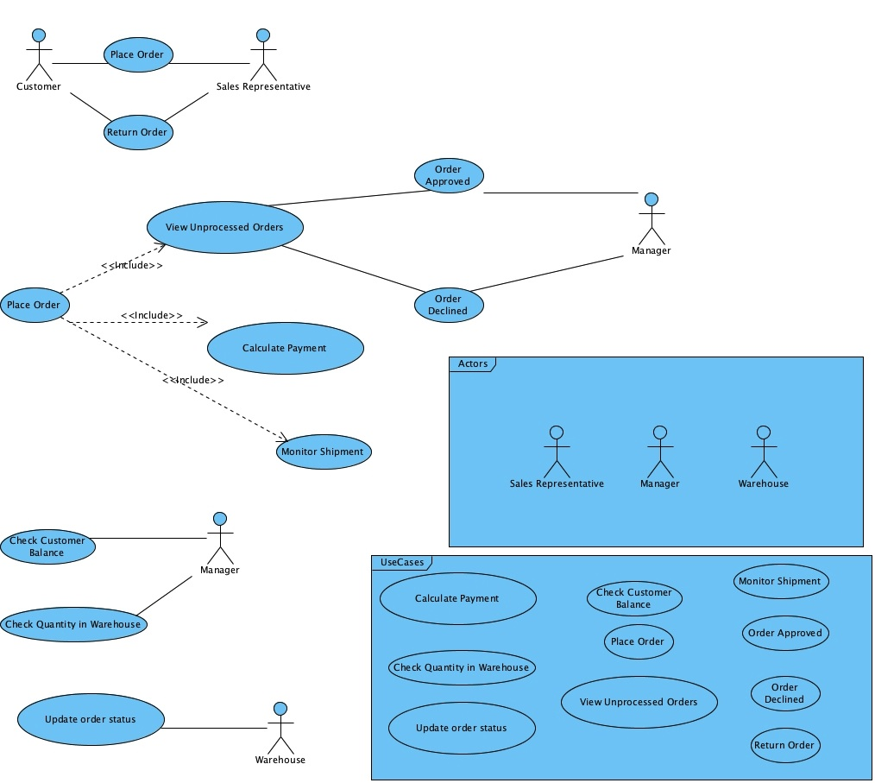
Figure 1 Use Case Diagram with Key

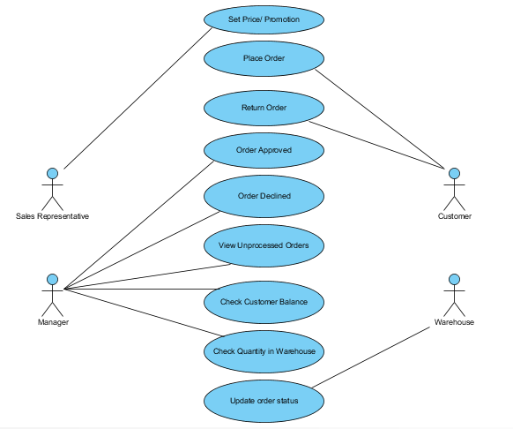
Figure 2 Use Case Diagram
This system will include 9 different use cases shown in the Use Case Diagram above. The are:

Use case 1: Add Customer; Set Price/Promotion:
Actor: Sales Representative | System
1- Selects “Add Customer” option from main menu.  3- Enters customers information including the price and promotion for selected products.  4- Clicks “Add Customer” button. | 2- Displays screen with input fields for data to be filled by user.  5- Displays the new customer added with prices and promotion.

Use case 2: Place Order
Actor: Customer | System
1- Selects “Place Order” option from main menu.  3- Enters order’s details.  4- Clicks “Finish and Submit” button. | 2- Displays screen with input fields for data to be filled by user.  5- Displays the order number.
Use case 3: Return Order
Actor: Customer | System
1- Selects “Return Order” option from main menu.  3- Enters order’s number, products, and reason for return  4- Clicks “Return” button. | 2- Displays screen with input fields for data to be filled by user.  5- Displays the confirmation after submitting the return order form.
Use case 4: Approve Order
Actor: Manager | System
1- Selects “Pending orders” option from main menu.  3- Selects order to be approved.  5- Selects customer history to check balance  7- Selects product’s availability.  9- Selects Approve order. | 2- Displays screen with pending orders  4-Opens order’s details.  6- Opens history, with customer’s balance page..  8- Open product’s availability page.  10- Displays the order’s stating and send notifications to order involved users.
Use case 5 : Decline Order
Actor: Manager | System
1- Selects “Pending orders” option from main menu.  3- Selects order to be approved.  5- Selects customer history to check balance  7- Selects product’s availability.  9- Selects Decline order. | 2- Displays screen with pending orders  4-Opens order’s details.  6- Opens history, with customer’s balance page..  8- Open product’s availability page.  10- Displays the order’s stating and send notifications to order involved users.

Use case 6 : Update Order Status
Actor: Warehouse Representative | System
1- Selects “Orders” option from main menu.  3- Selects order to be updated.  5- Enters the current status of the order. | 2- Displays screen with all orders  4-Opens order’s details.  6- Displays the updated order’s details.

Data Flow Diagram
Provide a description about DFD and draw it for your system
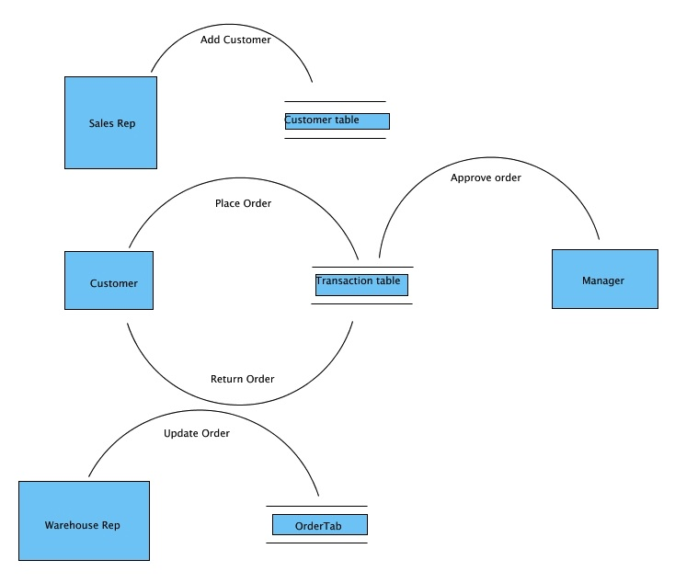
Figure 3 Data Flow Diagram
- A process is usually started physically when the sales representative meets with a potential customer.
- After agreement is made concerning the overall deal, the Sales representative will login to his account on the portal and adds the new customer and sets the prices and promotions they previously agreed upon.
- Once the customer is added, his username and password are sent to his procurement department by the sales representative.
- The customer can then login in to his account and place an order ( or return an existing order in other cases)
- The order is added to the transaction table, and the system notifies the manager that there is a pending order.
- The manager logs in and view the order’s details and can either approve (or decline) the order depending on both the customer’s current balance and products availability.
- After an order is approved, a pick slip is sent to the warehouse department to be processed.
- The Warehouse representative can login to the portal, view the orders and edit the status of each order enabling shipment tracking.

Class Diagram

Sequence Diagram

Business Process Model

Draw appropriate business process model and draw the as-is model and to-be model

User interface design
This section presents a story board for the user interface design. For example, if the project is a website, the story board provides a detailed description of the layout and components of each page. The User interface design of other projects would be the windows that appear when using the system, etc. We should mention here that System design components here are built to describe some website project. Students should take this an example only, and use it as a guide to write the system design that express their projects and handles their projects’ specifications.

Site Map:
An Example of Site Map, when the project is a website, is shown next.

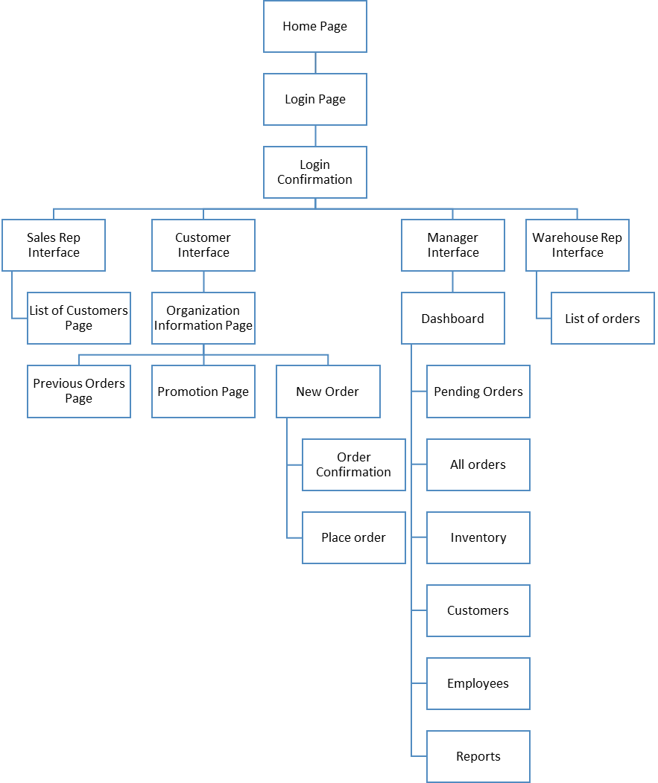
Figure 4 Site Map

Story board
As the user enters the URL for the portal, he is directed to the home page. The home page is divided into a link bar that includes links to the following pages:
- About Us
- Contact Us
- Feedback

This link bar will appear in all pages of the portal. Then comes the header section of the page. The body is divided into two parts: An introduction to the portal and a welcoming message, and an image. The homepage will include a link to the login page.

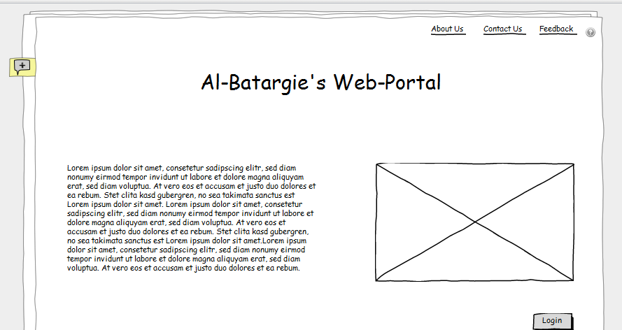
Figure 5 Homepage

The login in page will include a login plug-in, in which the user will enter his username and password. The user can click the remember me option, or be directed to another form if he forgot his password.
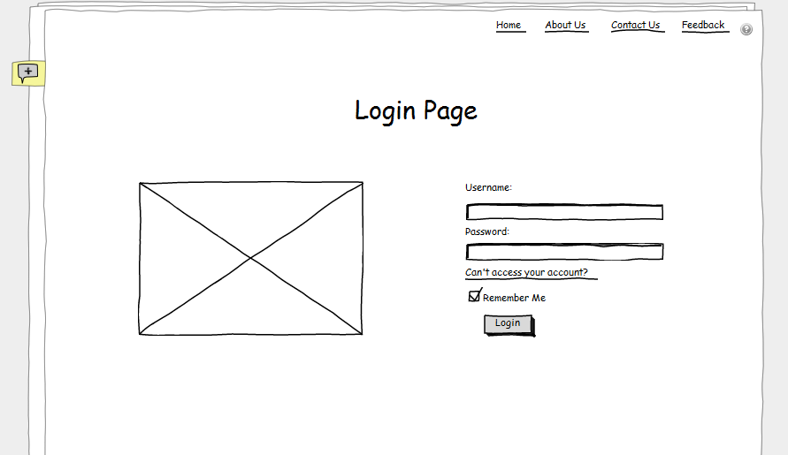
Figure 6 Login Page

After the user logins in, he will be directed to a confirmation page that will request that he checks his email to enter an automatically generated code that was sent by the system.
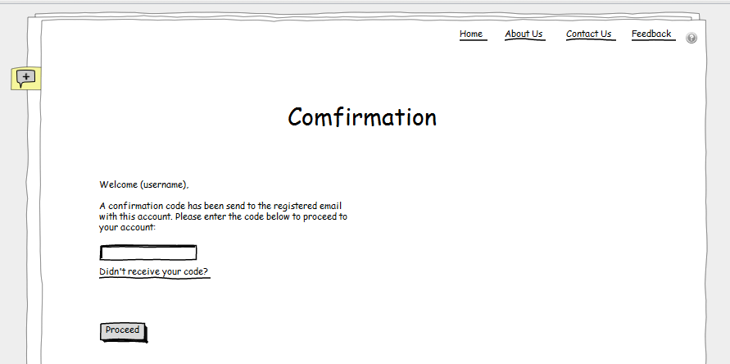
Figure 7 Confirmation Page

This system supports 4 types of users:
- Customers
- Sales Representatives
- Branch Managers
- Warehouse Representatives

If the user was a branch manager, he will be directed to the following dashboard in which he will have the following options to choose from:
  - View Pending Orders
  - View All Orders
  - View Inventory
  - View List of Customers
  - View List of Employees
  - Generate Reports

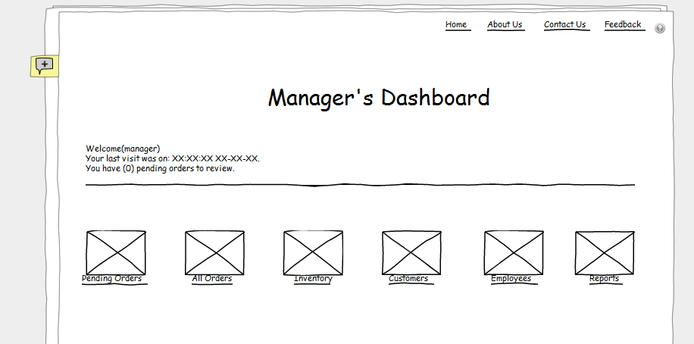
Figure 8 Manager's Dashboard

The manager can view all the pending orders he still needs to approve or reject. He can do so by clicking on the details link next to each order, view the orders details and customers history and the approve or reject. Whatever action the manager decides to take with the order, both the customer and sales representative will be notified.

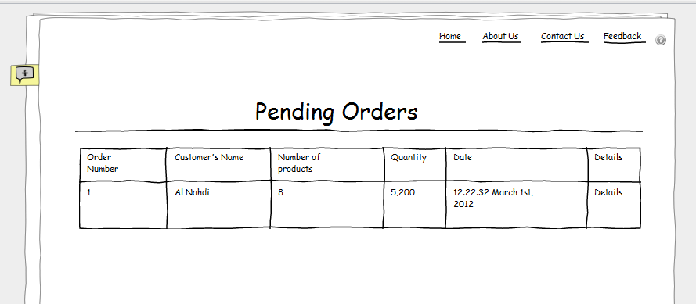
Figure 9 Pending Order Page
The manager can also view all the orders in his branch.

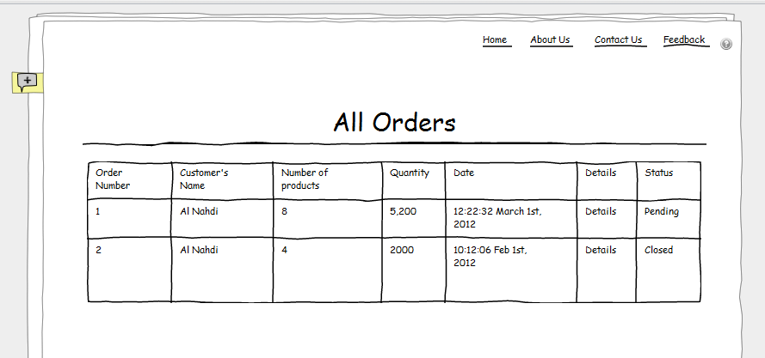
Figure 10 All Orders Page
The manager can check, and edit the available inventory level. This page will also help the manager in making the decision regarding approving or rejecting an order according to the availability of the product ordered.
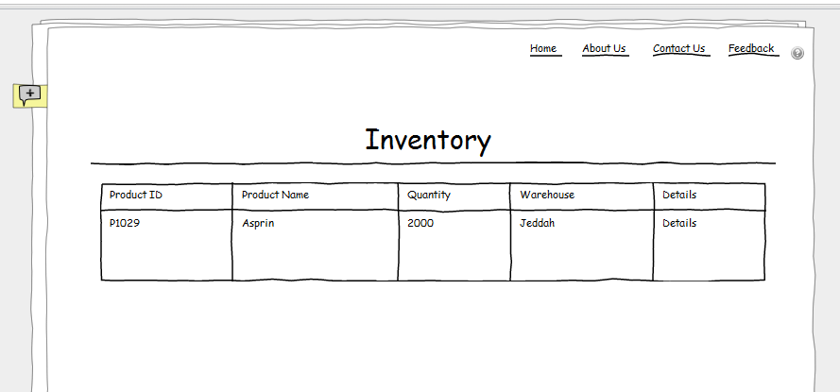
Figure 11 Inventory Page

The manager can also check the customers and the history of a certain customer. This page will help the manager in making the decision regarding approving or rejecting an order according to the balance of the customer.

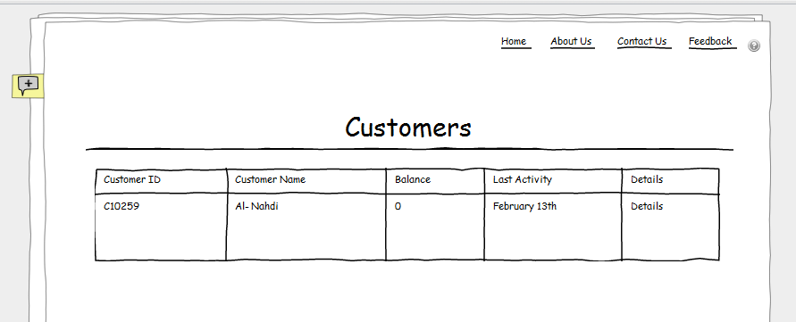
Figure 12 Customers Page
The manager can view the list of employees ( Sales and Warehouse representatives) registered to the system and update them.
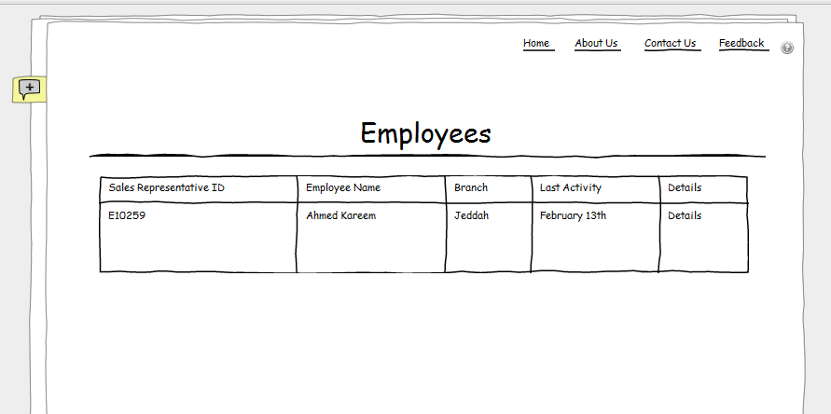
Figure 13 Employees Page

One of the main functions that the system needs to support for a manager is to generate reports. The manager can choose between 4 types of reports, and enter the time period to generate the report for. The types are:
- Pending Orders
- In Progress Orders
- Complete Orders
- Cancelled Orders

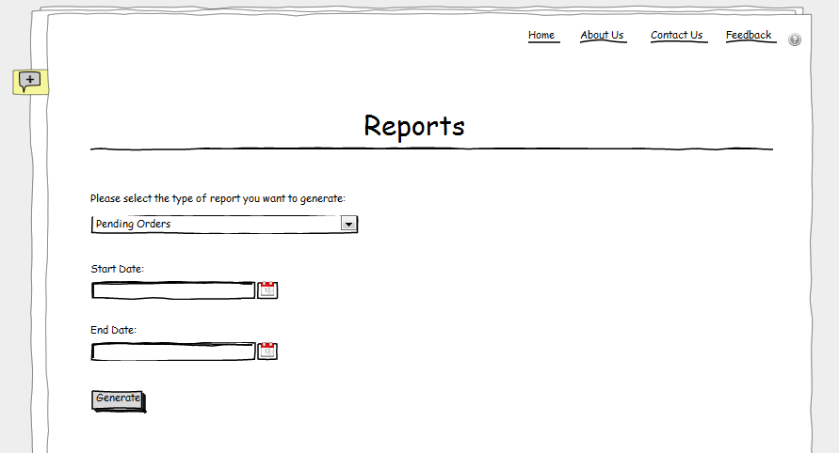
Figure 14 Reports Page

If the user logging into the system is a customer, he will be directed to this page that views some of the organization's details as well as links to 3 other pages:
- Previous Orders
- New Order
- Promotions

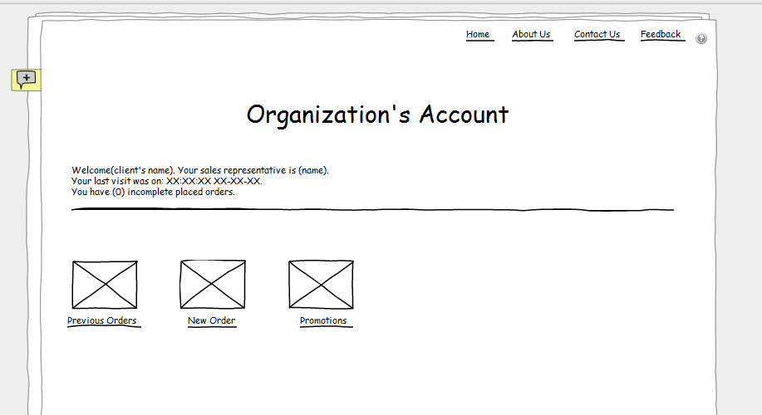
Figure 15 Organizations Page

The previous orders page views all the previous orders placed by the customer and their details.

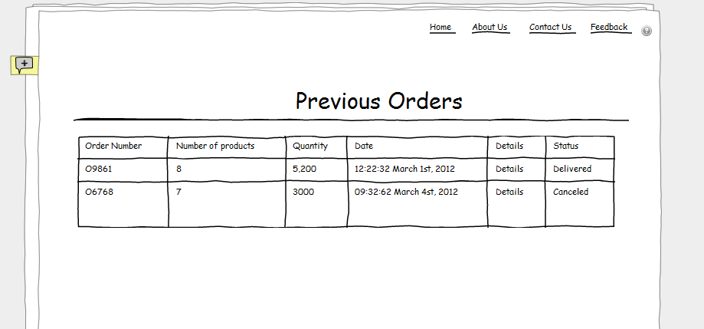
Figure 16 Previous Orders Page

When the customer clicks on the "New Order" link, he will first be directed to the following page. Since each organization (customer) is given only one account to log into the system, a list of some of the employees in that organization that can place an order is provided. The employee needs to pick his name from the list before continuing to the order form.

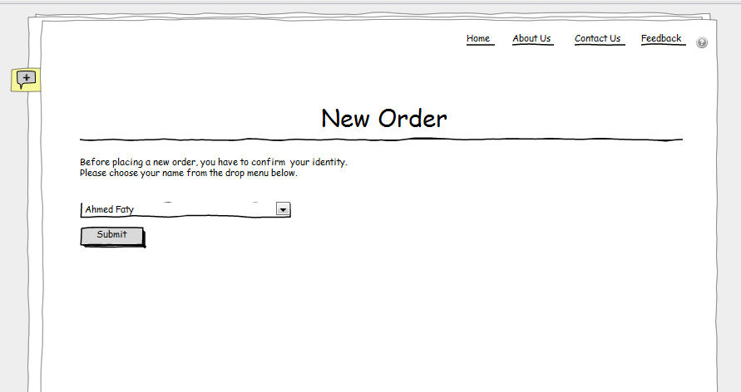
Once the employee chooses his name and submits, he will be directed to the placing order form. The employee needs to fill in the form once for every product he wishes to order. He can click on the "?" button to view the catalog if he forgot the products name or category as well.
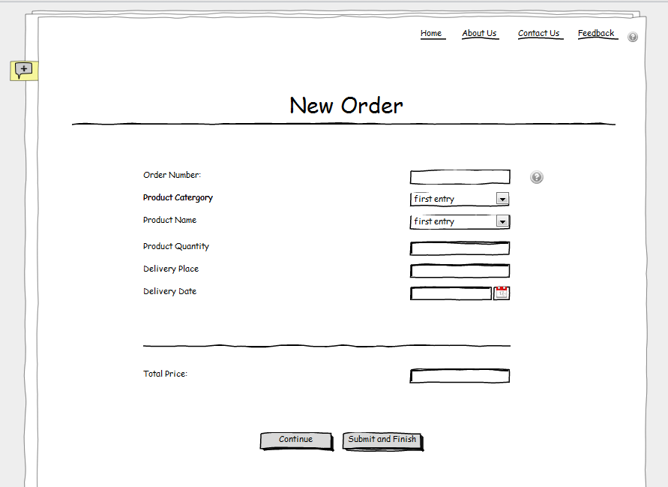
Once an order is completed and submitted, an order number will be given to it and sent to the client and sales representative by email.
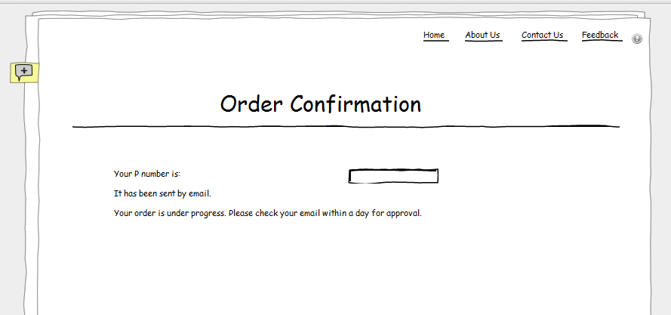

If the user logging in is a Sales Representative, he will be directed to his list of customers in which he can either add new customers he got, or edit the details of the existing ones.
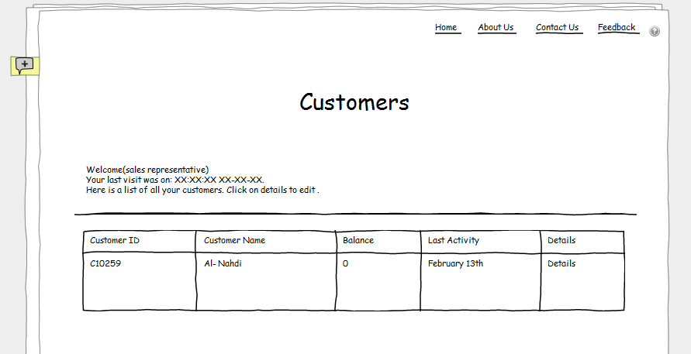
Figure 17 Customers List page

If the user logging in is a Warehouse Representative, he will be directed to the list of orders in which he edit the status to help enable shipment tracking.

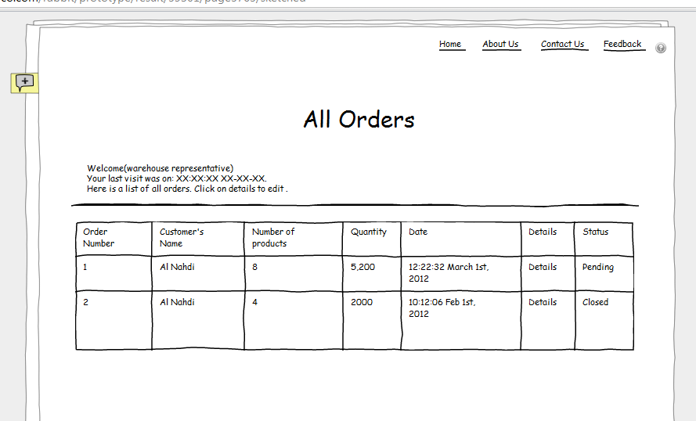
Figure 18 Orders Page

Data Model:
This section illustrates a detailed description of the data model, ER diagram, EER and the data dictionary in order to develop the database for the portal. For example, the following figure shows the detailed ER diagram and the data definitions of some project.
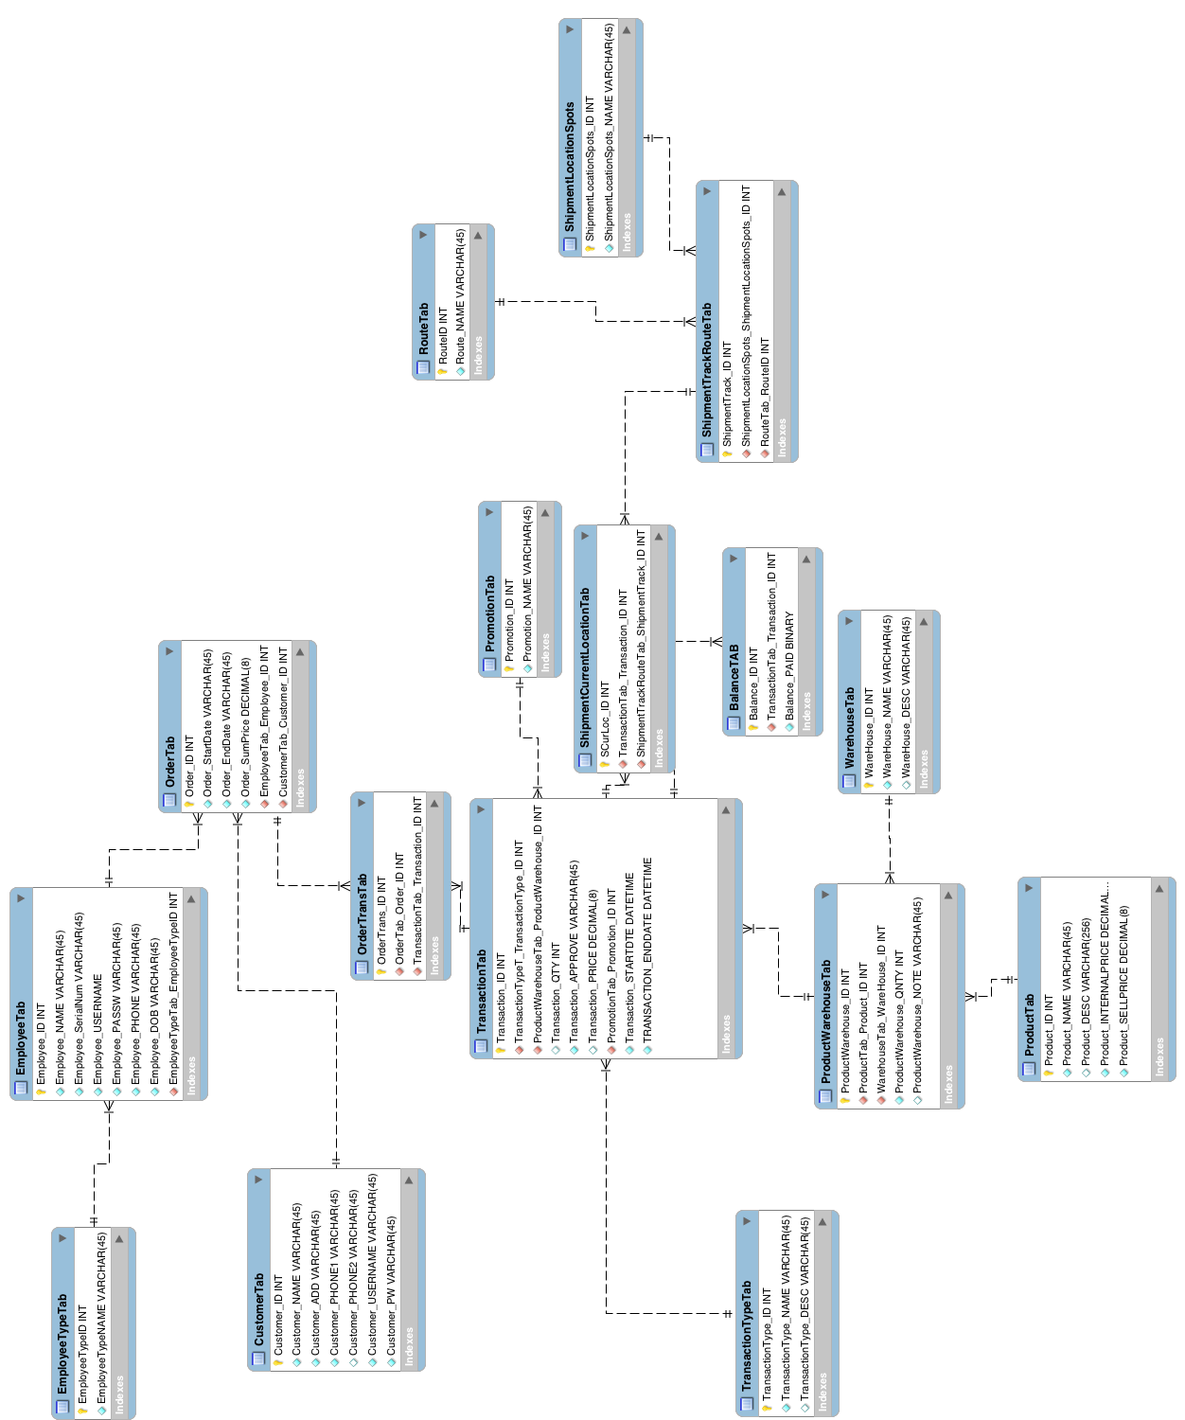
Figure 19 Entity Relationship Diagram

Conclusion

Conclusion:
Write few paragraphs (one to three) that conclude your project.

Difficulty faced:

While working on this project we have faced some problems and difficulties such as:
- Selecting a project subject/topic and finding a client.
- Analysis the current work flow in the company.
- Finding information about such systems and the databases required.
- Working on the relationships between the entities.
- Time management
- Designing a suitable interface.

Future Works:

Discuss your vision about your project. What you wanted to add, but you couldn’t because of resources limitations…what sections that planned to do, but you couldn’t because of time limitations…etc.

Reference

For graduation project 2 after the design section, please add the following section:
      - Implementation
        - Introduction
        - Tables, attributes and relations
        - Procedures/functions
        - Reports
        - Layouts
        - Reports layouts

